# CS 401 Group Project

Software Requirements Specification  
for the Distributed File System (DFS)

Revision History

|  |  |  |  |
| --- | --- | --- | --- |
| **Date** | **Revision** | **Description** | **Author** |
| 02/12/2022 | 1.1 | Initial Version | Miles Vizinau, Moises, Isaiah |
| 02/16/2022 | 1.2 | Edited Text | Miles Vizinau, Isaiah |
| 02/18/2022 | 1.3 | Included Use Case Templates | Issiah |
| 02/19/2022 | 1.4 | Edited Text, Included some Reference Diagrams | All |
| 02/20/2022 | 1.5 | Included Sequence diagram | Miles |
| 02/26/2022 | 1.6 | Modified Class Diagram and Module Requirements | Miles |
| 02/28/2022 | 1.7 | Added notes from 02/28 client meet. Yes to supervisor, no to encryption, system should scale indefinitely. | Issiah |
| 03/18/2022 | 1.8 | Updated Module Requirements and Class Diagram | Miles, Moises |
| 3/21/2022 | 1.9 | Updated User and Storage Module | All |
| 04/05/2022 | 2.0 | Updated to reflect design document | All |
| 04/16/2022 | 2.1 | Updated Assumptions, added “Log”class, and updated the class diagram | Miles |
| 04/27/2022 | 2.2 | Updated Client Module, added Request Module, and updated class diagram | Miles |
| 05/02/2022 | 2.3 | Updated Request Module & Class Diagram, added more Use Case Diagrams | Miles |
|  |  |  |  |
|  |  |  |  |
|  |  |  |  |
|  |  |  |  |
|  |  |  |  |

Table of Contents

1. Purpose 4

1.1. Scope 4

1.2. Definitions, Acronyms, Abbreviations 4

1.3. References 4

1.4. Overview 4

2. Overall Description 5

2.1. Product Perspective 5

2.2. Product Architecture 5

2.3. Product Functionality/Features 5

2.4. Constraints 5

2.5. Assumptions and Dependencies 5

3. Specific Requirements 6

3.1. Functional Requirements 6

3.2. External Interface Requirements 6

3.3. Internal Interface Requirements 7

4. Non-Functional Requirements 8

4.1. Security and Privacy Requirements 8

4.2. Environmental Requirements 8

4.3. Performance Requirements 8

# Purpose

This document outlines the requirements for the Distributed File System (DFS).

## Scope

This document will catalog the user, system, and hardware requirements for the DFS. It will not, however, document how these requirements will be implemented.

## Definitions, Acronyms, Abbreviations

**Distributed File System (DFS)**: The main purpose of the Distributed File System (DFS) is to allows users of physically distributed systems to share their data and resources by using a Common File System

**Node**: The physical hardware that software can be downloaded on, like a computer

**Client:** An application that's installed the node that can be used to communicate with the server software

**Server**: A computer or computer program which manages access to a centralized resource or service in a network

**User**: The physical person operating the hardware

## References

Use Case Specification Document

UML Use Case Diagrams Document

Class Diagrams

Sequence Diagrams

## Overview

The Distributed File System (DFS) is designed to act as a private storage system for a single company. As information leaking is an ever-present danger this system will ensure that only individuals associated with the company can access the file system

# Overall Description

## Product Perspective

## Product Architecture

The system will be organized into 7 major modules: the User module, the Node module, the Client module, the Server module, the Log Module, the Request Module, and the File module

## Product Functionality/Features

The high-level features of the system are as follows (see section 3 of this document for more detailed requirements that address these features):

* + - All files are hidden on users’ nodes
    - Any file type should be supported
    - Client software allows the user to talk to the server software
    - Server software keeps track of where files are located
    - Verified users should be allowed to access the DFS

## Constraints

* + - Employees have to request files from the server
    - Only employees can access the system (EX: using employee id & password)
    - Server doesn’t store files
    - Server has to already be running before any clients can connect

## Assumptions and Dependencies

* + - All employees have a verified ID and password issued by the company
      * All supervisor IDs start with an “!”
    - Only employees are using this software
    - The DFS software is installed only on a company computer
    - When searching for a specific file, the user should know the name and type of the file

# Specific Requirements

## Functional Requirements

### Common Requirements:

* Users will request files from the server software using the client software

### User Module Requirements:

* + - Supervisors can:
      * Remove any files from the list of files the server keeps track of
      * View the event history log
    - Users should have a User ID and password
      * Supervisors will have “S” as the 1st character in their ID
      * Non-supervisors won’t have “S” as the 1st character in their ID
    - Users should only be able to have open 1 piece of client software at a time

### File Module Requirements:

* + - Must contain file name
    - Must contain a file type

### Client Module Requirements:

* + - Contains a “**ClientHandler**” subclass
      * Handles the “Multi-thread” functionality
    - Should provide an interface for user to log in and out
    - Should be able to open and close the server
    - Should be able to send requests to server software for file operations
    - Should be able to send requests to server software for log operations
    - The client will prompt the user to decide whether they would like to: perform file operations, perform log operations, close the client, or close the client & server
      * Only supervisors can access: Log operations, access hidden files, and close the server

**3.1.5. Server Module Requirements:**

* + - Must have an event history (log)
    - Must have a list of nodes currently apart of the system
    - Must be able to handle multiple clients at a time
    - Supervisor can close the server and end access to application for current clients connected to it

**3.1.6. Node Module Requirements:**

* + - Must have a name
    - Only 1 user can be active on a node (computer) at a time
    - Node possesses 2 storage classes
      * Hidden storage class
      * Unhidden storage class

**3.1.7 Hidden Storage Class:**

* + - Has a list of files that we do not want everyone to have access to
    - To access hidden files, must be supervisor

**3.1.8 Unhidden Storage Class:**

* + - Has a list of files that everyone has access to

**3.1.9 Log Class:**

* + - Has a list of actions that’ve involved the server
    - Has a list of dates to match each action

**3.1.10 Request Class:**

* + - This is the object that’s being passed back and forth between the client and server
    - Acts as a container for attributes that need to be accessed by the client and server:
      * File
      * Log
      * Node

## External Interface Requirements

* + - The user must have direct access with the client software in order to have the server manage the files
    - The user should be provided an interface that allows them to log in to the DFS

## Internal Interface Requirements

* + - The system must process data from the user to a node (a computer); which contains the client software. The client software must send a request to the server file system and send the data back to the user
    - There exists an interface that encompasses both storage classes

# Non-Functional Requirements

## Security and Privacy Requirement

* + - Users with supervisor status should be given certain privileges
      * Access to event history of the DFS
      * Access to the complete file system
      * Ability to shut down the server
    - The system will NOT encrypt any data or files sent across the network.

## Environmental Requirements

* Every computer the company issues will have access to the same files using the DFS software
* The system will utilize the Java programming language.

## Performance Requirements

* System should be able to handle an indefinite number of clients and grow without constraint.

**Use Case Specification (Description) Template**

Use Case ID: *{0}*

Use Case Name: *{File Upload}*

Relevant Requirements: * *{3.1.1}*

Primary Actor: *{DFS Client}*

Pre-conditions: *{User must log in with valid ID and the file to upload must exist.}*

Post-conditions: *{If file does not already exist, file is uploaded to the DFS}*

Basic Flow or Main Scenario: *{Numbered flow of events: 1 The user logs in with ID, 2 The user requests to upload a file, 3 The user selects the file to upload, 4 The client uploads the file to the DFS*

Extensions or Alternate Flows: *{Alternatively, if the file already exists, prompt the user to choose whether they want to replace the identical file name or skip this action.}*

Exceptions: *{File no longer exists or cannot be found.}*

Related Use Cases: {File request}

**Use Case Specification (Description) Template**

Use Case ID: *{0}*

Use Case Name: *{File Request}*

Relevant Requirements: * *{3.1.1}*

Primary Actor: *{DFS Client}*

Pre-conditions: *{User must log in with valid ID.}*

Post-conditions: *{If the file requested exists, the client will request it from the server and it will be returned to the user.}*

Basic Flow or Main Scenario: *{Numbered flow of events: 1 The user logs in with their ID, 2 The user requests to retrieve a file, 3 The client checks with the server if the file exists, 4 If it does, file is returned to the user who requested it.}*

Extensions or Alternate Flows: *{Alternatively, if the file does not exist, then inform the user.}*

Exceptions: *{Error: file does not exist.}*

Related Use Cases: {File upload}

**Use Case Specification (Description) Template**

Use Case ID: *{1}*

Use Case Name: *{Supervisor privileges}*

Relevant Requirements: * *{4.1}*

Primary Actor: *{User/Supervisor}*

Pre-conditions: *{Supervisor must enter valid supervisor ID}*

Post-conditions: *{If ID is valid, the user will be granted access to the event history of the DFS as well as the entire file system.}*

Basic Flow or Main Scenario: *{Numbered flow of events: 1 The user logs in with their supervisor ID, 2 The user requests access to the event history or to the entire file system, 3 Access granted}*

Extensions or Alternate Flows: *{N/A}*

Exceptions: *{Invalid supervisor ID}*

Related Use Cases: {N/A}

**Use Case Specification Diagram(s)**

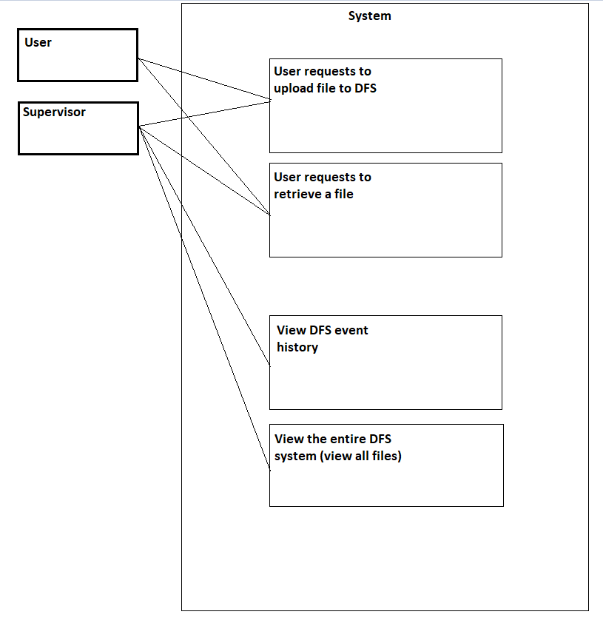

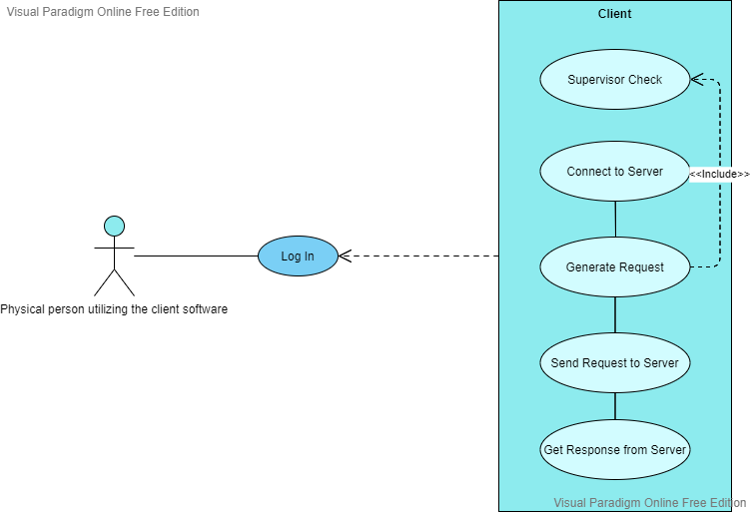

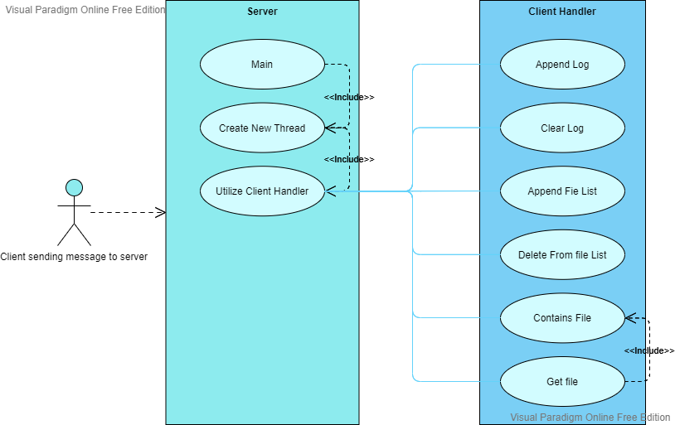

**Class Diagram(s)**

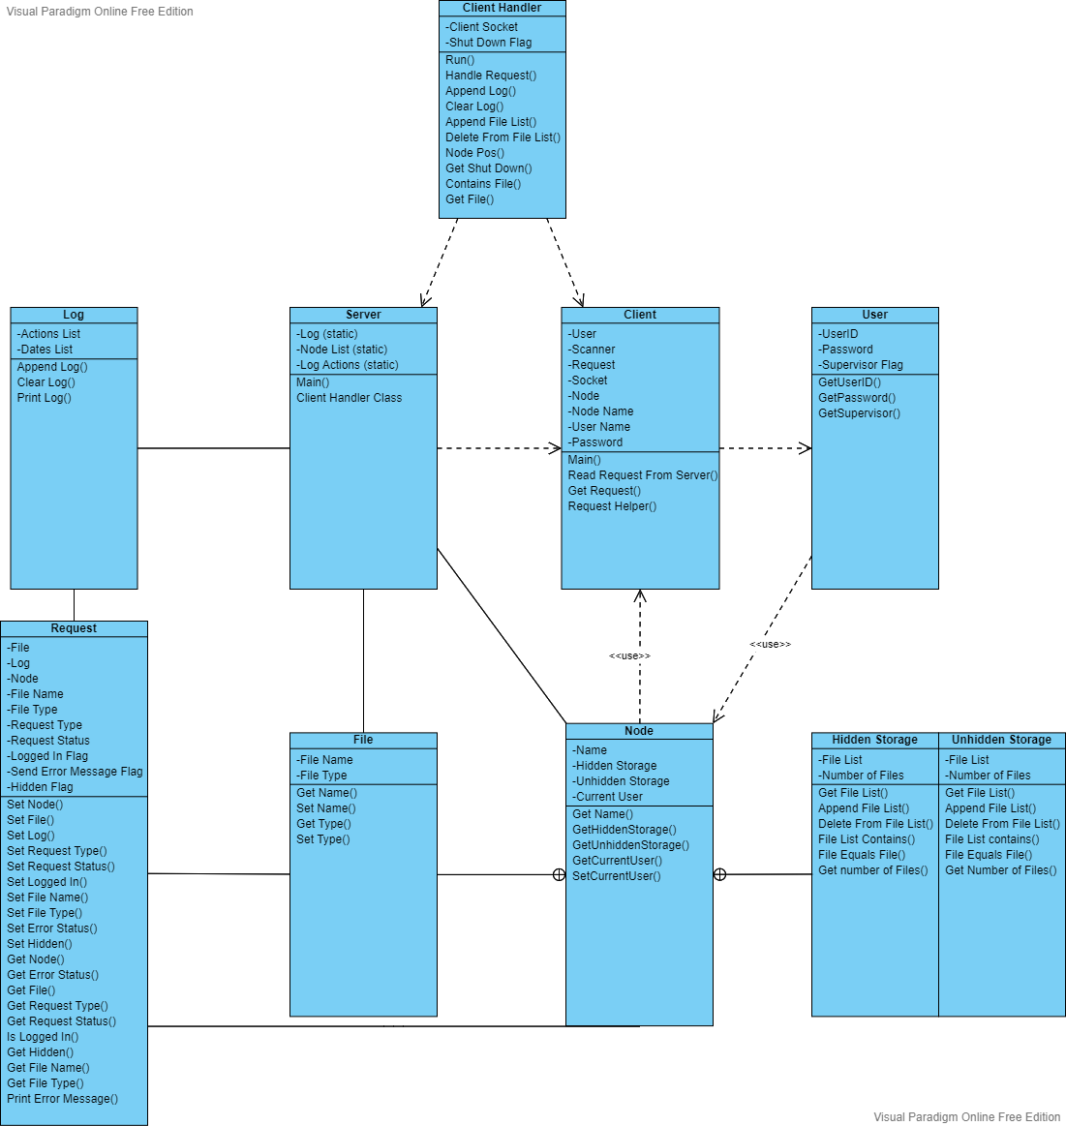

**Sequence Diagram(s)**

